**LIVROUTE**



**Supervisor**

Ma’am Alina Munir

**Submitted by**

Muhammad Salman  
{2021_SE_04}

Noman Ahmad  
{2021_SE_24}

Farjad Waseem  
{2021_SE_56}

**Department of Computer Science,**

University of Engineering and Technology, Lahore, New-Campus.

**TABLE OF CONTENT**

Description: 3

Scope: 3

Vision Statement: 3

Work Break-down Structure: 4

Requirements Analysis: 5

1. Functional Requirements: 5

2. Non Functional Requirements: 8

3. Physical Product Requirements: 10

4. Storyboards: 10

UML Diagrams: 13

1. Usecase Diagram: 13

2. Class Diagram: 14

3. Object Diagram: 15

4. Packager Diagram: 16

5. Deployment Diagram: 17

Timeline / Gantt Chart: 18

# Description:

Our team will be developing a bus tracking system that allows students, teachers, and staff to view live bus locations, routes, pickup points, and estimated time of arrival. The system will feature an admin dashboard for managing bus and driver information, routes, and pickup points, and sending custom notifications to all users. The system will use driver’s mobile phone as a GPS tracking system for the bus and include user-friendly interfaces for mobile platforms. Our goal is to create a secure, reliable, and user-friendly system that enhances the overall transportation experience.

# Scope:

The scope of route app involves the development of a software platform that enables the management for all bus routes. The system should be designed to facilitate the students and staff to view the stops and tracks of all the routes, their live location and also any alternative route their route is missed. The system should allow the driver to start and stop the route tracking. The system should also allow the admin to send to add or remove new route or stops in the route, add or block any user, driver and to assign a route to the driver.

# Vision Statement:

For students, staff members, and transport officers, who want to check and track their bus route via mobile app. KSK Routes is a bus route tracking app that will provide the facility to students and staff members to track their specific buses and the current location of the bus. Unlike Google Maps, the focus is to provide students and staff members an interactive UI and push notifications in case their route bus has started. Our product will lessen the transport office’s burden of managing everyday student-driver issues and provide students or staff members with effective ways to reach university in case their route is missed.

# Work Break-down Structure:

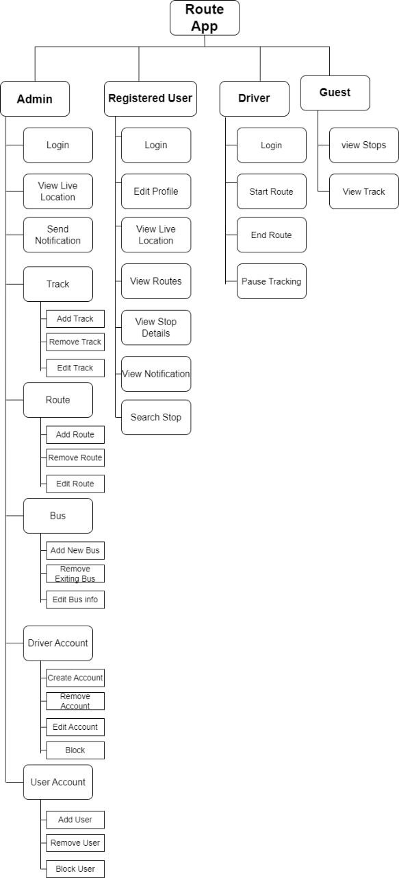

# Requirements Analysis:

## Functional Requirements:

1. **Admin Accounts**
2. Admin shall be able to add admin
3. Admin shall be able to import admin
4. Admin shall be able to export admin
5. Admin shall be able to block admin
6. Admin shall be able to unblock the blocked admin
7. Admin shall be able to remove admin
8. Admin shall be not be able to update upper-ranked admin
9. **Driver Accounts**
10. Admin shall be able to add driver
11. Admin shall be able to import driver
12. Admin shall be able to export driver
13. Admin shall be able to block driver
14. Admin shall be able to unblock the blocked driver
15. Admin shall be able to remove driver
16. **Members Accounts**
17. Admin shall be able to add members
18. Admin shall be able to import members
19. Admin shall be able to export members
20. Admin shall be able to block members
21. Admin shall be able to unblock the blocked members
22. Admin shall be able to remove members
23. **Updating Tracks**
24. Admin shall be able to add Track
25. Admin shall be able to import Tracks
26. Admin shall be able to export Tracks
27. Admin shall be able to remove Track
28. Admin shall be able to view Track
29. Admin shall be able to add stop in Track
30. Admin shall be able to remove stop in Track
31. Admin shall be able to edit stop in Track
32. Admin shall be able to build path with map in Track
33. Admin shall be able to copy path of one Track to another Track
34. Admin shall be able to edit path of Track
35. Admin shall be able to points in path of Track
36. **Updating Routes**
37. Admin shall be able to add Route
38. Admin shall be able to Import Routes
39. Admin shall be able to Export Routes
40. Admin shall be able to remove Route
41. Admin shall be able to edit Route
42. Admin shall be able to generate Timetable of Routes
43. Admin should be able to select Import mode of Route
44. **Bus Details**
45. Admin shall be able to add bus
46. Admin shall be able to remove bus
47. Admin shall be able to edit bus
48. Admin shall be able to export bus
49. **Tracking**
50. Admin shall be able to view Live Location of active routes
51. Admin shall be able to stop tracking of active routes
52. **Messages**
53. Admin shall be able to send messages to driver
54. Admin shall be able to send messages to members
55. Admin shall be able to delete send message
56. **Call**
57. Admin shall be able to call a driver.

## Non Functional Requirements:

1. **Admin Accounts**
2. System shall accept only CSV file as an Import of Admin Accounts
3. Admin shall be able to generate a CSV file as an export of Admin Accounts
4. System should automatically send notification to admin when he get blocked
5. Blocked Admin should not be able to login through its account
6. **Driver Accounts**
7. System shall accept only CSV file as an Import of Driver Accounts
8. Admin shall be able to generate a CSV file as an export of Driver Accounts
9. System should automatically send notification to driver when he get blocked
10. Blocked driver should not be able to login through its account
11. **Members Accounts**
12. System shall accept only CSV file as an Import of Members Accounts
13. Admin shall be able to generate a CSV file as an export of Members Accounts
14. System should automatically send notification to member when he get blocked
15. Blocked member should not be able to login through its account
16. **Updating Tracks**
17. System shall accept only CSV file as an Import of Tracks
18. Admin shall be able to generate a CSV file as an export of Tracks
19. System should automatically delete reference from routes of Deleted Track
20. System should not accept invalid format of text in a path of Track
21. **Updating Routes**
22. System shall accept only CSV file as an Import of Route
23. Admin shall be able to generate a CSV file as an export of Route
24. Admin must be able to select multiple option in Import of Route
25. System should have adding Tracks only option in Import of Route
26. System should have adding Bus only option in Import of Route
27. System should have adding Drivers only option in Import of Route
28. **Bus Details**
29. System shall accept only CSV file as an Import of Route
30. Admin shall be able to generate a CSV file as an export of Route
31. Tracking
32. System shall send notification to driver after admin stop it's tracking
33. **Messages**
34. System should send a notification if user receive a message
35. Admin shall be able to send message to Admin, Driver and Members.
36. **Call**
37. System should allow only one admin on a call with one driver.

## Physical Product Requirements:

* Computer Hardware
* Mobile Devices
* Internet Connection

## Storyboards:

### Admin

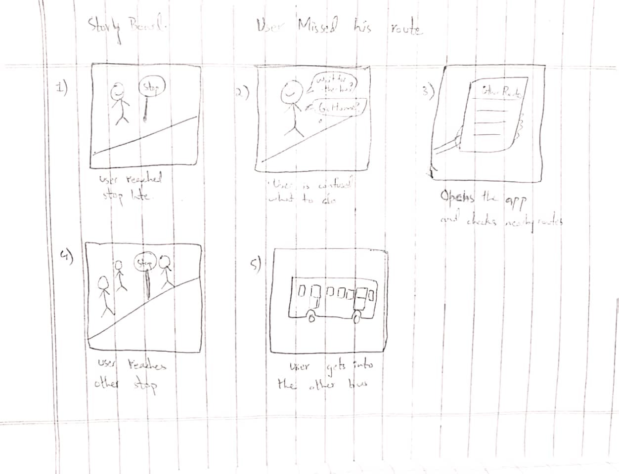

### Driver

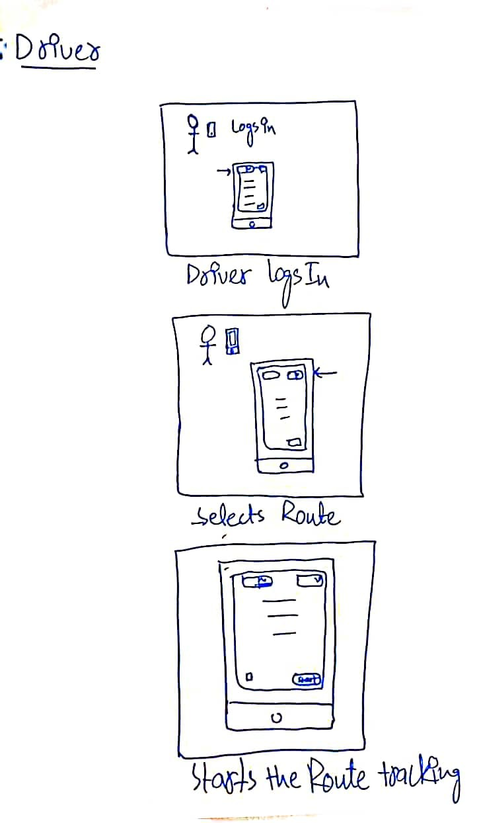

### Member

### story (2)

# UML Diagrams:

## Usecase Diagram:

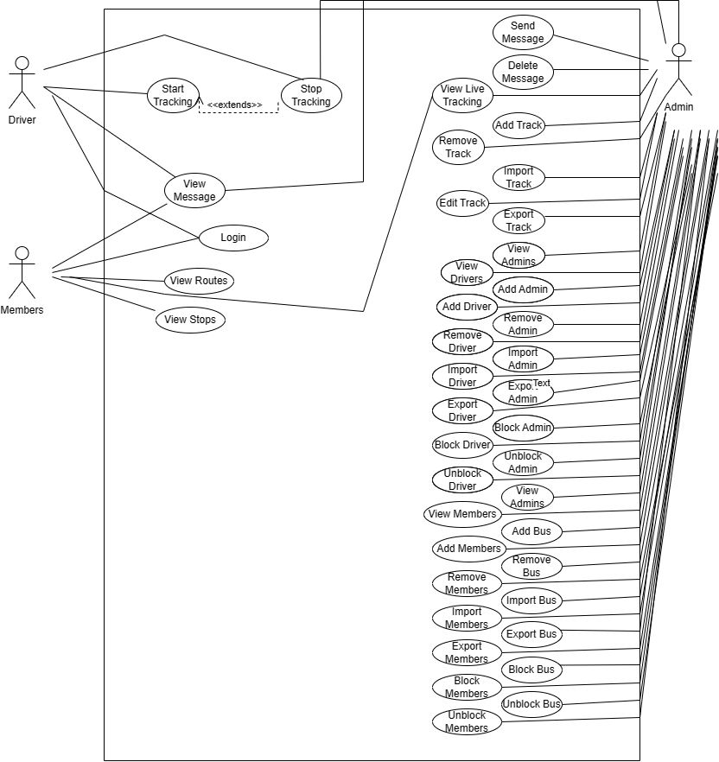

## Class Diagram:

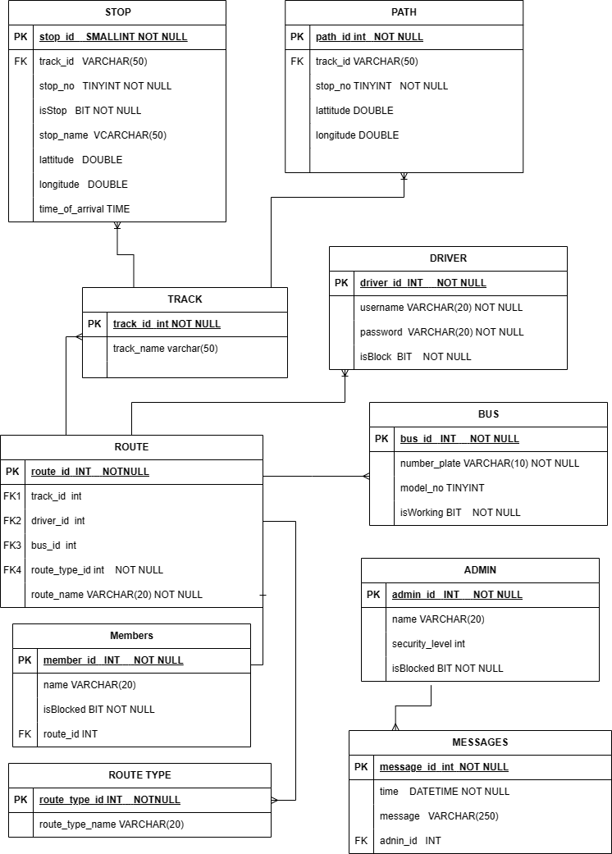

## Object Diagram:

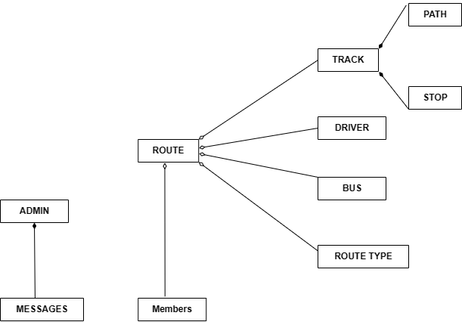

## Packager Diagram:

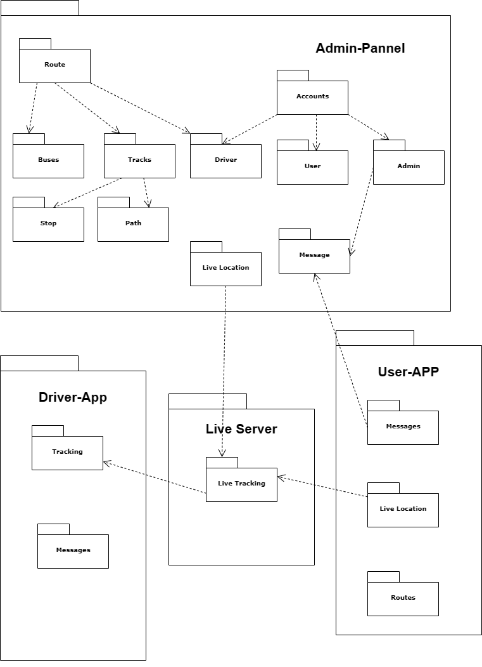

## Deployment Diagram:

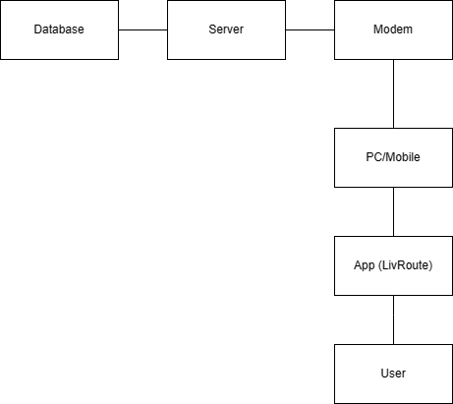

# Timeline / Gantt Chart:

|  |  |  |  |  |
| --- | --- | --- | --- | --- |
| Steps | First Week | Second Week | Third Week | Fourth Week |
| Scope,Vision of the project |  |  |  |  |
| Requirement of the Project |  |  |  |  |
| Story Boards of the Project |  |  |  |  |
| Use Cases |  |  |  |  |
| UML Diagrams of the project |  |  |  |  |
| Test Cases |  |  |  |  |
| Building of the prototype |  |  |  |  |